Welcome to the May 2013 issue of the Charlotte SAE Alumni Association Newsletter. Contact us if you have any information you want to add. Email John Stringfellow at jstringman@aol.com.
Social Calendar
Wednesday, July 10 – Home of Brother Stephen T. Burgess, ’71 Florida Beta/FSU, 6722 Honors Court, Charlotte, NC (SouthPark area), starting at 7 pm. Casual attire, dates and spouses are welcome, and food with light beverage provided. Contact Steve at (704) 553-8362 if you can attend, or email stephen_burgess@ml.com.
Spotlight

Meet Brother David M Schweppe, ’94 Virginia Sigma/Washington & Lee, an attorney with the firm of Schweppe & Schweppe. He is a Shelby, North Carolina native. He attended Washington and Lee University in Lexington, Virginia where he earned athletic honors as a varsity tennis player. David obtained is law degree at Campbell University School of Law. During law school, David interned with a leading criminal defense attorney in Raleigh, North Carolina. After graduation, David broadened his legal experience by joining a large Raleigh firm where he concentrated on commercial litigation. In 1999, David returned to Shelby and joined The Schweppe Law Firm, P.A where he expanded the practice to include criminal defense, personal injury, and business litigation. During his career, David has made court appearances in 60 of North Carolina’s 100 counties. David is married, has 3 children, and enjoys golf, tennis, snow skiing and water sports. Reach David at 704-243-5124.
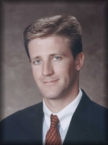
Bryan A Mudd, DDS, ’93 Maryland OP/Univ of Md Baltimore, is a partner in the dental firm of SouthPark Dentistry. He graduated from University of Maryland with a Doctor of Dental Surgery in 1997. He was in private practice in Maryland from 1997-2001 before moving to Charlotte. He writes: “I have enjoyed becoming a part of the Charlotte community since locating here from Maryland in 2001. I hope to give patients open communication and honest treatment that they deserve and can understand. We also desire to provide this care in a relaxing and inviting environment.” His interests include golf, boating and traveling with his family and friends. Contact Bryan at email bmudd@carolina.rr.com.

Brother Wes Grasty, ’91 NC Xi/UNC, operates an internet marketing company as a consultant. He writes: “I started my own e-commerce business in 2005 and have learned a lot over the years. I love passing that knowledge on to other small businesses and helping them grow in the process. My consulting services include SEO, Usability/User Experience, Social Media, Conversion Optimization, Email Marketing and anything else that will improve your website. I offer a free website analysis. Just email me your website name and give me a few days and I will respond with your free report.” Contact Wes at wgrasty@hotmail.com.
NC Beta News (UNC Charlotte) - http://saencbeta.com
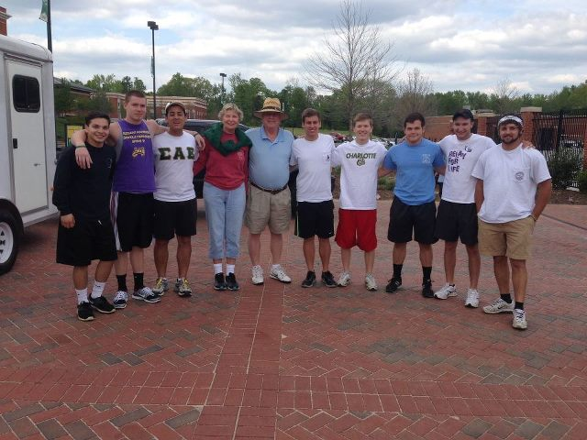
Coming back from Phi Alpha retreat for the UNCC IFC Run for Boston. Includes Johnny White, Chapter Advisor (fifth from the left) and Dr. Janice Hinson, Faculty Advisor (4th from left). In addition, Hector Cortes (far left), Nick Woolard (second from left), Aaron Lucas (third from left), Alex McGrail (fifth from right), Ben Ellis (third from right), Matthew Grindstaff (far right).

- Visit their FACEBOOK PAGE here.
- The chapter won the Air Band Competition at Greek Week for 2013. See it on You Tube here
- The first ever Paddy Murphy week was held and the winners were the ladies of Delta Zeta. The chapter raised $500 for community service.
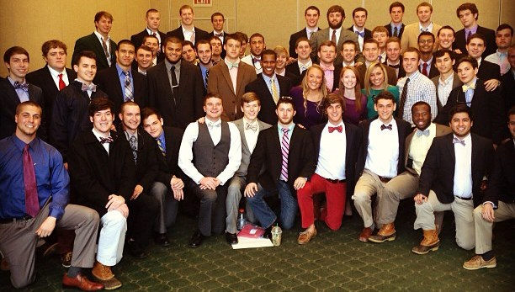
- The brothers won the Province Omicron SAE Singing Award for 2013. Video here.
Thomas C Toth, ’91 Penn Phi/Carnegie Mellon, is a senior vice president with the Bank of America. He was a vice president at Citigroup from 1996 to 2001. Tom obtained his MS Degree in Industrial Automation at Carnegie Mellon University – Tepper School of Business in 1995. Married to Denver, they have 2 children – Alexander and Mason. Reach out to Tom at thomasctoth@hotmail.com.

Spring 2013, Theta Pledge Class Initiation

NC Theta News (Davidson) – www.davidsonsae.edu
Additional New Officers for 2013
Academic Chm - James Helzberg Kitchen Manager - Austin Elliott Gray
Service Chairmen - Ryan Emerick and Peter Bowman
Judicial Board (PCC) – Ali Kaussari
Standards Board – Mas Gore and Sperry Edwards
Rush Chairmen – Andrew Kelleher, Willie MacDade, Jack McDowell
Social Chairmen – Cyrus Saffari and John Marsh
Sustainability Chair – Joe CullenHouse Chairman - William King

Brothers Elected to Student Government
Congratulations are in order for the current SAEs that won Davidson College Student Government Association President (Christopher Ragsdale) and Vice President (Nicholas McGuire).

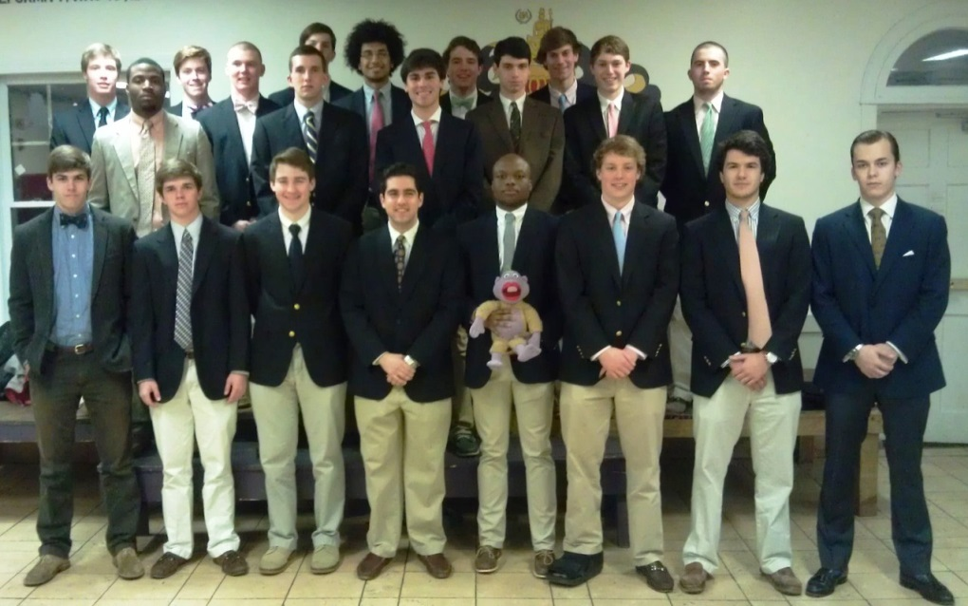
Congratulations to the Spring 2013 Pledge Class – 21 new members

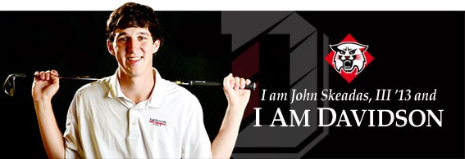

John Skeadas, '13, was featured on the Davidson Golf Team and the Wildcats athletic site.
•Named to the All Southern Conference team for the 2011-12 season
•Finished the sophomore and junior campaigns with the second best scoring average on the team
•Earned a second place finish at the 2011-12 season opening Mason Rudolph Championship
...
Province Omicron News
Alumnus Running for Supreme Council

SAE will have its bi annual convention this summer (2013) in Chicago, June 29-July 2. Brother Mike Corelli, Province Omicron Archon, has announced his campaign to run for the Eminent Supreme Chronicler position on the Supreme Council. He was Eminent Archon of his Illinois Gamma Chapter, and serves as the Associate Director of Leadership Programs and Director of the Office of Leadership and Student Involvement at Western Carolina University. Visit his FACEBOOK Page to learn more about this distinguished alumnus. Support Mike by writing him at email mikecorelli@gmail.com or phone 847-830-0836.

Spotlight – William Grasty

William Townson Grasty ’92 NC Xi/UNC, serves as Director of Institutional Marketing at Kingfisher Capital, leading the firm’s global outreach efforts, as well as overseeing sales and marketing. He serves as a primary point of contact for prospective investors and institutions and works closely with clients to manage relationships on behalf of the firm. Prior to Kingfisher, William had a similar role with WealthTrust Advisors. William has held various management roles in marketing, strategy and business development roles at Hewlett Packard, and worked closely with HP's venture capital group, focusing on the emerging technologies arena. Prior to joining HP, William was an investment banker with First Union Capital Markets (a predecessor to Wachovia Securities and Wells Fargo Securities) in their high yield origination group. Prior to joining First Union’s Investment Banking Group, he served as a credit analyst for the Bank, identifying and structuring various financing solutions across a variety of industries for middle market, corporate, and institutional clients. He started his career in commercial banking, completing the Corporate Management Training Program at First Union National Bank. William has studied and worked abroad and traveled the world extensively, participating in international education programs and global corporate banking internships, in Spain and Argentina, respectively. William earned a B.A in Political Science and a B.A. in Spanish from the University of North Carolina at Chapel Hill. He holds a M.B.A. from Vanderbilt’s Owen School of Management, graduating with a dual concentration in Finance and E-Commerce. William lives in Charlotte with his wife and three children. Contact him at william@kingfishercapital.com.

CSAE Survey
We want to hear from you! Please complete our online survey so we can make sure that our programs and mission are meeting your needs. Click here or choose the icon to the left to reach the survey. Thanks for your feedback!
Hosts Needed
We are looking for alumni to host socials for the Association in 2013. Please contact John Stringfellow at email jstringman@aol.com if interested for the details.
Spotlight – Rick Booth, ’87 SC Gamma/Wofford – President, Intrepid Artists

Rick was born and raised in Charlotte, NC where his love for music started at a very young age when his Godmother gave him a copy of Elton John’s Greatest Hits for his 10th birthday. From that point on, he could not get enough. In high school, it was not unusual at all to find Rick out sneaking in to bars and music venues to try to get his live music fix.
He continued his love for live music in college. Rick graduated from Wofford College with a degree in Sociology in 1987. While attending Wofford, he served as Social Chairman of his fraternity, Sigma Alpha Epsilon, for 2 years and began his personal work with bands and booking bands for different social events and his fraternity.
After graduating from Wofford, Rick came home to Charlotte and worked as a manager in the family Hardware business for almost 3 yrs. Rick credits many of his managerial skills to his Dad who ran the family business for 35 plus years. Rick says, “He taught me the right way and wrong way to treat people. Having a degree in Sociology did not hurt either. Recognizing how to deal with people sure does help out when dealing with all the personalities in the music business. I am a People Person.”
By 1990, it was time for a career change and Rick went to work for a regional music agency, Hit Attractions for a very short time. This was booking mostly cover bands and college bands. By the end of the year, Rick was ready to make another change and went to work for Piedmont Talent, a blues agency that booked all original Blues Bands and some Louisiana Cajun and Zydeco Bands as well. After 4 plus years at Piedmont, Rick felt it was a great time to go out on his own and bring his own spin to ,the music industry.
Intrepid Artists Int’l was officially open for business Dec 19, 1994. Since that time, Intrepid has far out exceeded his original highest expectations. Intrepid or one of it’s agents has been the recipient of the prestigious Keeping The Blues Alive Award a record 3 times, in 1997, 2002, and most recently in 2011. Since 2008, Intrepid’s artists have received over 80 Blues Music Award nominations and 4 Grammy nominations. Today, things have never been better at Intrepid! With the largest, strongest staff to date, Intrepid is prepared to step into the next decade as the premiere Blues & Roots Rock Music Agency of it’s kind. Over the years, both clients and customers alike of Intrepid have learned that both Rick Booth and his entire staff are the most personal, reliable, honest, and accountable people you will find in the business. That combined with the great stable of Artists is what makes Intrepid unique.
Reach out to Rick at email rick@intrepidartists.com.
Alumni Notes
Julien B Booth, ’88 NC Alpha/NCSU, is principal and portfolio manager for Forest Capital in Concord and Charlotte. With a forestry background, Julien found many parallels between the practice of responsible forestry and the practice of asset management. Julien’s investment philosophy dovetails with this background as he takes a conservative, long-term approach to managing investment capital for growth and sustainability. His credentials include 17 years experience in portfolio management and analysis, SEC/NC/MO Registered Investment Advisor, and a BS in Forest Management from North Carolina State University. Reach Julien at email jbooth@forestcapital.net.
T. Scott Brumley, ’87 SC Gamma/Wofford, is owner of T Scott Brumley, CPA in Huntersville. After attending Wofford, he got an accounting degree at UNC Greensboro. Visit his web site at http://www.brumley.com/ if you have tax questions or needs. Married to Geri, they have 5 children: Jessica, Trey, Ben, Curt, Dillan, & Taylor. Reach out to Scott at scott@brumley.com.
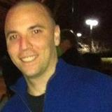
Jeff Bunting, ’05 New York Chi/Hofstra, is an occupational therapist and staff member at the Dowd YMCA (greet him at the front desk). Welcome him to Charlotte via email at jdbunting25@gmail.com. Originally from Clarksburg, WV, he obtained his degree from West Virginia University. He attended Robert C Byrd High School.
Jeff Gifford ’88 FL Upsilon/University of Florida, is chief financial officer for the VSTH Group in Charlotte. VSTH is a privately held merchant bank providing investment banking services and private equity investment backed by our own capital. Jeff has over fifteen years of experience as a CPA specializing in M&A tax matters for strategic and financial investors. Jeff previously led the tax transaction advisory practice at both Arthur Andersen and Grant Thornton in Charlotte. Contact Jeff at jgifford@vsth.com.
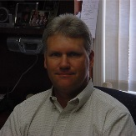
James P Gill, ’80 SC Gamma/Wofford, is the owner and agent with Gill & Young Insurance in Rock Hill. Gill Insurance was founded in 1961 by John A. Gill and Clarence Albright. It was originally called Albright-Gill Insurance and was located on Black Street. In 1978, Mr. Gill merged with Jim Young to form Gill & Young Insurance. Their office was located on North Avenue. In 1991, the office moved to their current location at 235 Oakland Avenue. Contact Jim at email jamesgill@comporium.net.


National News
In this month when we remember those who have departed our company, we encourage you to help the Sigma Alpha Epsilon Foundation honor our brothers who joined Chapter Eternal while they served in the Armed Forces. The goal is to display 1,500 flags on the Levere Memorial Temple lawn during Memorial Day weekend to honor our fallen SAEs. Each flag represents a brother who lost his life in any of our nation’s conflicts — from the Civil War through the current war. For each $25 donation to the Memorial Day Tribute Campaign, the Foundation will place one flag in the ground at our headquarters. Donations must be made by May 26, 2013. Gifts can be made by phone, by mail or online: (847) 424-3021; www.sae.net/donate (Select “SAE Memorial Day”); Sigma Alpha Epsilon Foundation, ATTN: SAE Memorial Day – 13USA, 1856 Sheridan Road, Evanston, IL 60201-3837
Officer & Chapter Contacts
- Secretary: John Stringfellow, Email jstringman@aol.com
- President Emeritus: Bob Millice, Email NCsaeBob@yahoo.com
- NC Beta Advisor: Johnny White, Email johnny@whitegroupcarolinas.com
- Eminent Archon, NC Theta at Davidson – Sam Gray, Email sgray@davidson.edu
- Eminent Archon, NC Beta at UNCC – Evan Wardrop, Email ewardrop@uncc.edu
- Province Omicron Archon – Mike Corelli, Email corelli@wcu.edu

