10:00am: Pre-service prayer in conference

room

10:30am: Pastor Benny Kjiersdam
“Growing in the Spirit”
Maintaining Your Soul

10:30 am NURSERY FOR 0 – 23 months
(Parent/guardian will need to sign in & sign out the child)

The following children will be dismissed during the service.

TODDLER CHURCH FOR 2-4 YEARS
(Parent/guardian of toddlers will need to sign in & sign out the child)

SUPERCHURCH FOR 5-10 YEARS

CHILDREN’S MINISTRIES

Needs: Pasta, pasta sauce, pancake mix and syrup, soup, cans of ham, chicken, tuna, can vegetables, soda crackers and Kraft Dinner.

General Fund Budget: $19,000
General Fund Received in September:
$6,697.00
Monthly Mortgage Payment: $2,500
Mortgage money received for September: $0
Special Furnace Offering:
$12,986.00
Thank you for your faithfulness in the giving of your tithes and offerings.

Audrey King, Debbie and Al Ramsay, Al’s father John Ramsay, Rob Wilson-Debbie & Al’s son, Connie Holmes, Lee Chamberlain, David Hazzard-National Director PAOC, Linda & Randy Reid’s daughter in law Julie
---------------------------------------------------------------------------------------
The Pastor and congregation offer their condolences to Tim and Melody Kahtava & family on the passing of Tim’s dad-Yorma Kahtava.
--------------------------------------------------------------------------------------
The Pastor and congregation offer their condolences to the Turcotte family on the passing of Deanne.

Wednesday, September 11, 2019
2:00-3:30pm Bible Study
6:30pm Parents Café and Kids in the Kitchen

Thursday, September 12, 2019
6:15pm Youth
6:30pm Parents Café and Kids in the Kitchen

Sunday, September 15, 2019
10:30am Anthony Zappacosta-Gideon’s speaker

Saturday, September 21, 2019
9-4 Work Bee at Elim

Sunday, September 22, 2019
6:00pm Men’s Ministries

Monday, September 23, 2019
7:00 pm Small Group @ Moran’s

Friday, September 27th
12:00pm Ladies Bible Study

Sunday, September 29th evening
Special Musical Worship Service
Led by the Araba’s

Bible Study
Wednesdays 2:00-3:00pm
Led by: Pastor Benny Kjiersdam

Men’s Ministries
Sunday, September 3, 2019 @ 6:00pm
Leader: Greg Komhyr
Theme: The Church in Babylon- Heeding the Call to Be a Light in the Darkness by Erwin W. Lutzer

ELIM MINISTRIES

UPCOMING EVENTS
FINANCES
SEPTEMBER 8, 2019
CHILDREN’S MINISTRIES
PRAYER REQUESTS
MANNA MINISTRY

Rivers of Living Water
John 7:37-39
Grow in the Spirit


Rivers of Living Water
John 7:37-39
Grow in the Spirit
The library is full, please do not bring in any material until further notice. Thank you.
------------------------------------------------------------------------------------------------
Offering Information
Different ways you can give your tithes to the church.
1) Offering plate in service
-cash -cheques
-we do offer assigned envelopes
2) Automatic withdrawal-withdrawn on the 28th of each month from your bank account. See Cathy Thomas for more information.
3)EMT-email transfer (Interac e-transfer)
For this avenue see Nelson Cooper or Sven Svantesson
---------------------------------------------------------------------------------------------
Work Bee
Saturday, September 21, 2019
9-4pm
Please sign up-see bulletin board
------------------------------------------
New Small Group
Mon. September 23th @ 7:00pm
(will take place every Monday evening)
Leader: Pastor Ed Moran
Where: 105 Oryme Ave.
Theme: How to Share Your Faith Without an Argument.
------------------------------------------------------
Parents Café volunteers your schedules for 2019/2020 year are in your mailboxes.
--------------------------------------------------------------------------------------------- Kids in the Kitchen needs 7 – 2-quart casserole dishes. If you have a 2-quart glass casserole dish you no longer need, we would be happy to accept it. Thank you.

What good will it be for someone to gain the whole world, yet forfeit their soul? Or what can anyone give in exchange for their soul? Matthew 16:26

For in him all things were created: things in heaven and on earth, visible and invisible, whether thrones or powers or rulers or authorities; all things have been created through him and for him. Colossians 1:16

Above all else, guard your heart, for everything you do flows from it. Proverbs 4:23

Therefore, remember that formerly you who are Gentiles by birth and called “uncircumcised” by those who call themselves “the circumcision” (which is done in the body by human hands)—
Ephesians 2:1

For the wages of sin is death, but the gift of God is eternal life in Christ Jesus our Lord. Romans 6:23

But if we walk in the light, as he is in the light, we have fellowship with one another, and the blood of Jesus, his Son, purifies us from all sin. 1 John 1:7

“But God said to him, ‘You fool! This very night your life will be demanded from you. Then who will get what you have prepared for yourself?’ Luke 12:20

For we must all appear before the judgment seat of Christ, so that each of us may receive what is due us for the things done while in the body, whether good or bad. 2 Corinthians 5:10

And I heard a loud voice from the throne saying, “Look! God’s dwelling place is now among the people, and he will dwell with them. They will be his people, and God himself will be with them and be their God. ⁴ ‘He will wipe every tear from their eyes. There will be no more death’ or mourning or crying or pain, for the old order of things has passed away.” Revelation 21:3-4

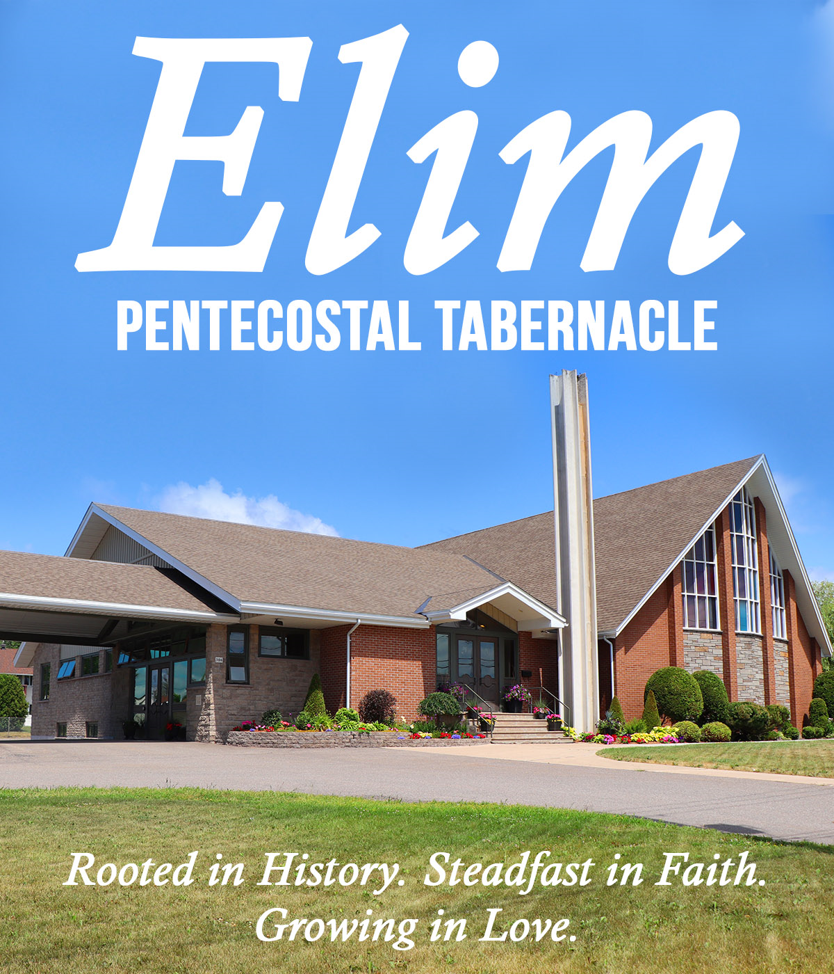
SCRIPTURES

.

Hearing Apparatus: There are 4 sets available, please see an usher if you have a need.
SEPTEMBER 8, 2019

Pastoral Staff
Lead Pastor: Rev. Benny Kjiersdam
Youth Pastor: Pastor Luigi Fontana
Church Administrator/Children’s Ministry Director: Cathy Thomas

Office Hours
Tuesday – Friday 9:00am – 4:00pm
306 McNabb St., Sault Ste Marie ON
P6B 1Y6

Phone: (705) 942-2010 Fax: (705) 942-8653
Email: secretaryelim@shaw.ca
Web: www.elimchurchonline.com
Facebook address: Elim Pentecostal Tabernacle@ElimSaultSteMarie

