10:00am: Pre-service prayer in conference

room

10:30am: Pastor Benny Kjiersdam
“Growing in the Spirit”
(Guarding our Mind)

10:30 am NURSERY FOR 0 – 23 months
(Parent/guardian will need to sign in & sign out the child)

The following children will be dismissed during the service.

TODDLER CHURCH FOR 2-4 YEARS
(Parent/guardian of toddlers will need to sign in & sign out the child)

SUPERCHURCH FOR 5-10 YEARS

CHILDREN’S MINISTRIES

Needs: Pasta, pasta sauce, pancake mix and syrup, soup, cans of ham, chicken, tuna, can vegetables, soda crackers and Kraft Dinner.

General Fund Budget: $19,000
General Fund Received in September:
$16,382.50
Monthly Mortgage Payment: $2,500
Mortgage money received for September: $680.00
Special Furnace Offering:
$14,236.00
Thank you for your faithfulness in the giving of your tithes and offerings.

Amelia Burns, Debbie and Al Ramsay, Al’s father John Ramsay, Rob Wilson-Debbie & Al’s son, Dale Robertson’s parents, Lee Chamberlain, Linda & Randy Reid’s daughter in law Julie
---------------------------------------------------------------------------------------
Our prayers are with Sharron Kordupel as she has moved to Guelph to be with her children. Wishing her God’s best. The Pastor and congregation would like to thank Sharron Kordupel for overseeing Operation Christmas Child Shoeboxes for many years. Carol Lewis has agreed to head up this ministry now.
-----------------------------------------------------------
Ladies Bible Study
Date: Every Friday
Time: 12:00-12:45pm
Theme: Be Anxious for Nothing
Leader: Judy Watts
Bring your lunch

Wednesday, September 25, 2019
2:00-3:30pm Bible Study
6:30pm Parents Café and Kids in the Kitchen

Thursday, September 26, 2019
6:15pm Youth
6:30pm Parents Café and Kids in the Kitchen

Sunday, September 29th evening
Special Musical Worship Service
Led by the Araba’s

Monday, September 30, 2019
7:00 pm Small Group @ Moran’s

Friday, October 4, 2019
12:00pm Ladies Bible Study

Sunday, October 6, 2019
2-3pm Life Chain

Sunday, October 20, 2019
6:00pm Small Groups @ Robertson’s-details to follow

Sunday, October 27, 2019
6:00pm Men’s Ministries

Bible Study
Wednesdays 2:00-3:00pm
Led by: Pastor Benny Kjiersdam
New Small Group
Mon. September 23th @ 7:00pm
(will take place every Monday evening)
Leader: Pastor Ed Moran
Where: 105 Oryme Ave.
Theme: How to Share Your Faith Without an Argument.
Please sign up if you plan on attending.

ELIM MINISTRIES

UPCOMING EVENTS
FINANCES
SEPTEMBER 22, 2019
CHILDREN’S MINISTRIES
PRAYER REQUESTS
MANNA MINISTRY

Rivers of Living Water
John 7:37-39
Grow in the Spirit


Rivers of Living Water
John 7:37-39
Grow in the Spirit
Offering Information
Different ways you can give your tithes to the church.
1) Offering plate in service
-cash -cheques
-we do offer assigned envelopes
2) Automatic withdrawal-withdrawn on the 28th of each month from your bank account. See Cathy Thomas for more information.
3)EMT-email transfer (Interac e-transfer)
For this avenue see Nelson Cooper or
Sven Svantesson
---------------------------------------------------------------------------------------------
Men’s Ministries
Sunday, September 22, 2019
@ 6:00pm
Leader: Greg Komhyr
Theme: The Church in Babylon- Heeding the Call to Be a Light in the Darkness by Erwin W. Lutzer
-If you would like to purchase the book contact the Christian books store. Cost: $19.99 + 10% off if you tell them you are from Elim.
---------------------------------------------------------------------------------------------
Note from the Pregnancy Centre
There are 8 baby bottles that were not returned on Father’s Day in June. If you have one please return it to the office. Thank you for your support.
-------------------------------------------------------------------------------------------
Christmas Presentation
“Considering Christmas”
Dec. 22 @ 10:30am & Dec. 24 @ 7:00pm
Information on insert. If you’re interested in getting involved please contact Liz Moran-705-206-4780 or see sign-up sheet on the bulletin board.
---------------------------------------------------------------
Life Chain
Date: Sunday, October 6th Time: 2-3pm
Sign up list in foyer
- pick up banners @ 1:45 @ Elim

Therefore, I urge you, brothers and sisters, in view of God’s mercy, to offer your bodies as a living sacrifice, holy and pleasing to God—this is your true and proper worship. ² Do not conform to the pattern of this world, but be transformed by the renewing of your mind. Then you will be able to test and approve what God’s will is—his good, pleasing and perfect will.
Romans 12:1-2

…to be made new in the attitude of your minds… Ephesians 4:23

For though we live in the world, we do not wage war as the world does. ⁴ The weapons we fight with are not the weapons of the world. On the contrary, they have divine power to demolish strongholds. ⁵ We demolish arguments and every pretension that sets itself up against the knowledge of God, and we take captive every thought to make it obedient to Christ. 2 Corinthians 10:3-5

“In your anger do not sin”: Do not let the sun go down while you are still angry, ²⁷ and do not give the devil a foothold. Ephesians 4:26-27

Therefore, each of you must put off falsehood and speak truthfully to your neighbor, for we are all members of one body. ²⁶ “In your anger do not sin”: Do not let the sun go down while you are still angry, ²⁷ and do not give the devil a foothold. ²⁸ Anyone who has been stealing must steal no longer, but must work, doing something useful with their own hands, that they may have something to share with those in need. ²⁹ Do not let any unwholesome talk come out of your mouths, but only what is helpful for building others up according to their needs, that it may benefit those who listen. ³⁰ And do not grieve the Holy Spirit of God, with whom you were sealed for the day of redemption. ³¹ Get rid of all bitterness, rage and anger, brawling and slander, along with every form of malice. ³² Be kind and compassionate to one another, forgiving each other, just as in Christ God forgave you. Ephesians 4:25-32

Finally, brothers and sisters, whatever is true, whatever is noble, whatever is right, whatever is pure, whatever is lovely, whatever is admirable—if anything is excellent or praiseworthy—think about such things. Philippians 4:8

…but whose delight is in the law of the Lord, and who meditates on his law day and night. Psalm 1:2

Above all else, guard your heart, for everything you do flows from it. Proverbs 4:23

For as he thinketh in his heart, so is he: Eat and drink, saith he to thee; but his heart is not with thee. Proverbs 23:7

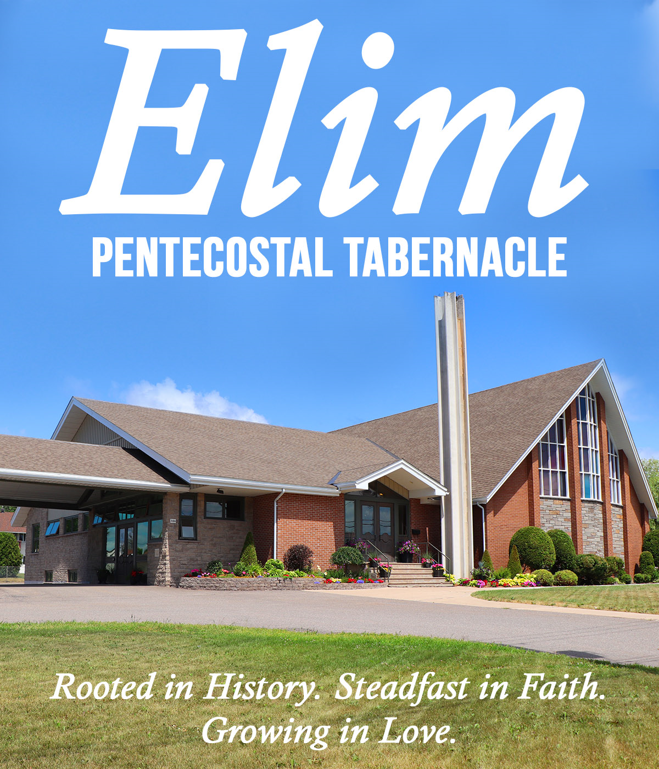
SCRIPTURES

.

Hearing Apparatus: There are 4 sets available, please see an usher if you have a need.
SEPTEMBER 22, 2019

Pastoral Staff
Lead Pastor: Rev. Benny Kjiersdam
Youth Pastor: Pastor Luigi Fontana
Church Administrator/Children’s Ministry Director: Cathy Thomas

Office Hours
Tuesday – Friday 9:00am – 4:00pm
306 McNabb St., Sault Ste Marie ON
P6B 1Y6

Phone: (705) 942-2010 Fax: (705) 942-8653
Email: secretaryelim@shaw.ca
Web: www.elimchurchonline.com
Facebook address: Elim Pentecostal Tabernacle@ElimSaultSteMarie

