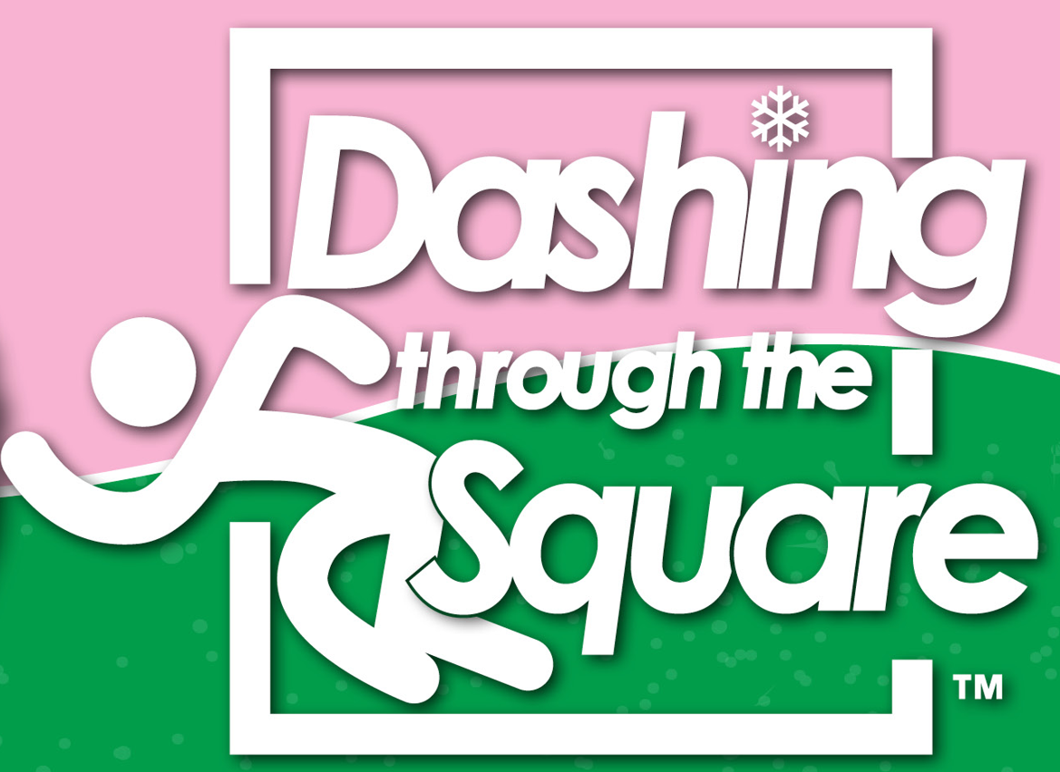
Sponsorship Benefits
Thank you for your interest in sponsoring the 8th Annual Dashing through the Square - 5K Race/Virtual Race/Kids 1K to be held on Saturday, December 16, 2023. Please see the sponsorship opportunities below. We thank you in advance for your generous contribution which is tax deductible: Tax ID #: 56-2638674
Title Sponsor - $3,500
- Company logo prominently displayed on T-shirts and The PEARL Foundation website and social media pages.
- Company logo printed on Swag Bag given to all registered race participants.
- Company/organization name featured on all printed programs and community service events.
- A special thank you in Pre-Race announcements.
- Printed materials (i.e., coupons, store discounts, etc.) and/or promotional items (i.e., pens, hats, visors, lotion) to go in packets that each runner will receive. No food or drinks.
- Six (6) Complimentary race entries
- Sponsor table at the race
- Donations due by November 1, 2023
Platinum Sponsor - $2,500
- Company logo displayed on T-shirts and The PEARL Foundation website and social media pages
- Company/organization name featured on all printed programs and community service events.
- A special thank you in Pre-Race announcements.
- Printed materials (i.e., coupons, store discounts, etc.) and/or promotional items (i.e., pens, hats, visors, lotion) to go in packets that each runner will receive. No food or drinks.
- Five (5) Complimentary race entries
- Sponsor table at the race
- Donations due by November 1, 2023

Diamond Sponsor - $1,000

- Company logo displayed on T-shirt and The PEARL Foundation website and social media pages.
- A special thank you in Pre-Race announcements.
- Printed materials (i.e., coupons, store discounts, etc.) and/or promotional items (i.e., pens, hats, visors, lotion) to go in packets that each runner will receive. No food or drinks.
- Three (3) Complimentary race entries
- Sponsor table at the race
- Donations due by November 1, 2023

Silver Sponsor - $500
- Company logo displayed on The PEARL Foundation website and social media pages.
- A special thank you in Pre-Race announcements.
- Printed materials (i.e., coupons, store discounts, etc.) and/or promotional items (i.e., pens, hats, visors, lotion) to go in packets that each runner will receive. No food or drinks.
- Two (2) Complimentary race entries
- Donations due by November 1, 2023
Pearl Sponsor - $250
- A special thank you in Pre-Race announcements.
- One (1) Complimentary race entry
- Donations due by November 1, 2023

Mile Marker Sponsor - $200

- Company logo/name on mile markers at one-mile intervals, one finish line marker and one start line marker.
- A special thank you in Pre-Race announcements.
- Donations due by November 1, 2023
Note: This is a total of eight (8) markers.
First come/First serve.

PAYMENT OPTIONS:

Make Checks Payable to: The PEARL Foundation, Inc. (Indicate soliciting Rho Zeta Omega member’s name in the memo section)

Mail to:

The PEARL Foundation, Inc.
Attn: PEARL Financial Secretary P.O. Box 674198
Marietta, GA 30006-0015

Via PayPal: Indicate soliciting Rho Zeta Omega member’s name in the memo/notes section.

www.thepearlfoundationga.org/donate

2023 Sponsorship Form

Thank you for your interest in sponsoring the 8th Annual Dashing through the Square 5K Race/Virtual 5K/Kids 1K to be held on Saturday, December 16, 2023 at the Historic Marietta Square, Marietta, GA.
Today’s Date: ___________________________________________________________________________
Organization Name: ______________________________________________________________________
Address: ______________________________________________________________________
Contact Person: ______________________________________________________________________
Contact Email: ______________________________________________________________________
Phone Number: ______________________________________________________________________
Website Address: ______________________________________________________________________
Soliciting Rho Zeta Omega Member: _________________________________________________________
1. Sponsorship level (please check one):
Title Sponsor (Only one) ☐ Platinum Sponsor ☐ Diamond Sponsor ☐
Silver Sponsor ☐ Pearl Sponsor ☐ Mile Markers / Start / Finish (8 Total) ☐
2. Do you plan to send coupons/store discounts to be distributed in the runner’s packet: YES ☐ NO ☐
Due Date: November 1, 2023
3. Please write your company name exactly how you would like it to appear on website, social media pages, etc. You will be notified with instructions to upload your logo, once payment has been received.
_______________________________________________________________________________________
4. Do you need a table on the day of the race? (Diamond, Platinum, Title Sponsors Only) YES ☐ NO ☐

5. Please identify your complimentary race participants:
1. _______________________________________ T-Shirt Size: S M L XL 2X 3X
2. _______________________________________ T-Shirt Size: S M L XL 2X 3X
3. _______________________________________ T-Shirt Size: S M L XL 2X 3X
4. _______________________________________ T-Shirt Size: S M L XL 2X 3X
5. _______________________________________ T-S hirt Size: S M L XL 2X 3X
6. _______________________________________ T-Shirt Size: S M L XL 2X 3X

PAYMENT OPTIONS:

Make Checks Payable to: The PEARL Foundation, Inc. (Indicate soliciting Rho Zeta Omega member’s name in the memo section)

Mail to:

The PEARL Foundation, Inc.
Attn: PEARL Financial Secretary P.O. Box 674198
Marietta, GA 30006-0015

Via PayPal: Indicate soliciting Rho Zeta Omega member’s name in the memo/notes section.

www.thepearlfoundationga.org/donate

